คู่มือ programmer
- com86 architecture
- deifference between minix and minxc on com86(Edit function)
- version and design flow
- os profile

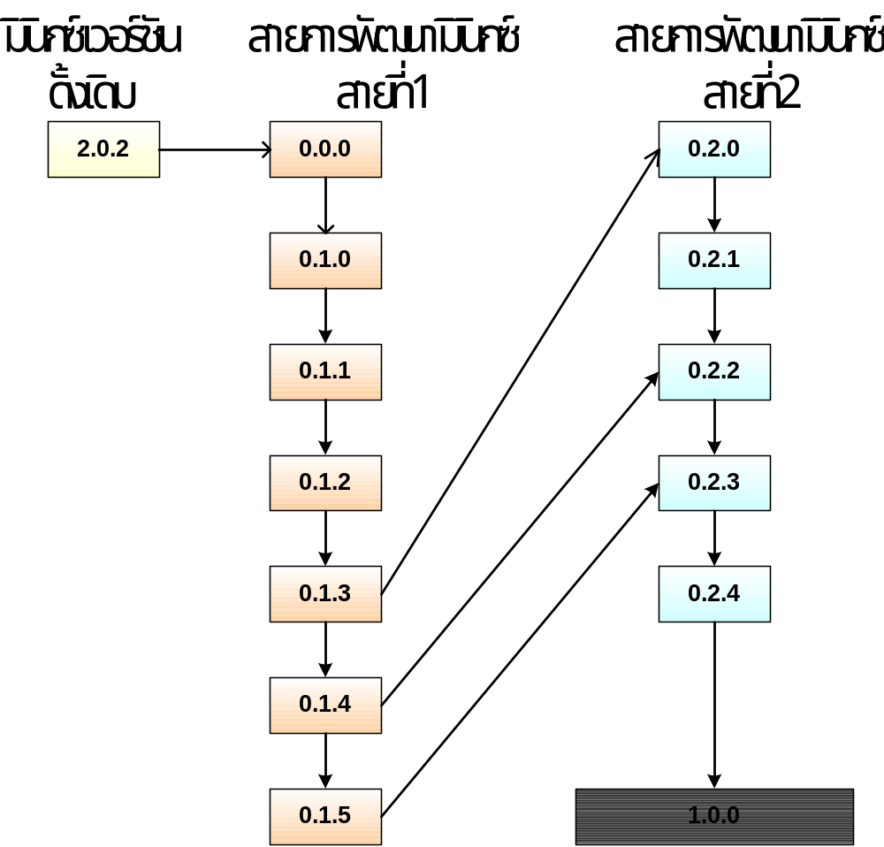

picture 1 development flow

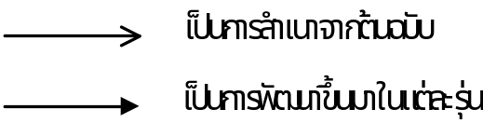

picture 2 notation

